Student’s Name
Professor’s Name
Course
Date
Laocoon Copy B-The William Blake Archive
William Blake archive demonstrates the figures that accompany the poems that Blake wrote. Laocoon Copy B is one of Blake’s extraordinary pieces of art that shows the struggle between morality and logos. The statue was constructed in 1820 to provide a background of Blake’s context of divinity. Laocoon is a pictorial illustration and depiction of good and evil in Blake’s archive. The statue comprises of Blake’s interpretation of the divinity. The figure shows Jehova and two sons, Satan and Adam. The three individuals are bound by two serpents, which according to Blake’s poem “Laocoon” represents evil and good. In Blake’s view, the angel of the divine presence was an imposter. Blake tries to differentiate the orthodox god of popular religion citing that it was an emissary and imposter that is often mistaken for God. He writes that “Good and evil are; riches and poverty a tree of; misery; propagating; generation and death” (Blake 1-5).
Blake’s statue further demonstrates the syncretic connection between Hebrew’s version and Greek’s version of God. In Blake’s view, the emissary that is often mistaken as God is bound, enslaved and entwined. However, the statue also represents Blake’s mind interpretation of the heavenly war in which the military army of angels engaged in what he described as a war in heaven. This war also exists in the human mind as Blake demonstrates in paradise lost where people struggle to choose between their desires and reason, good and evil, left and right, right and wrong. All these divisive dualities are caused by the actual imposter, which according to Blake’s poem, says that is responsible for dissociating the state of mind that generates the divisive dualities.
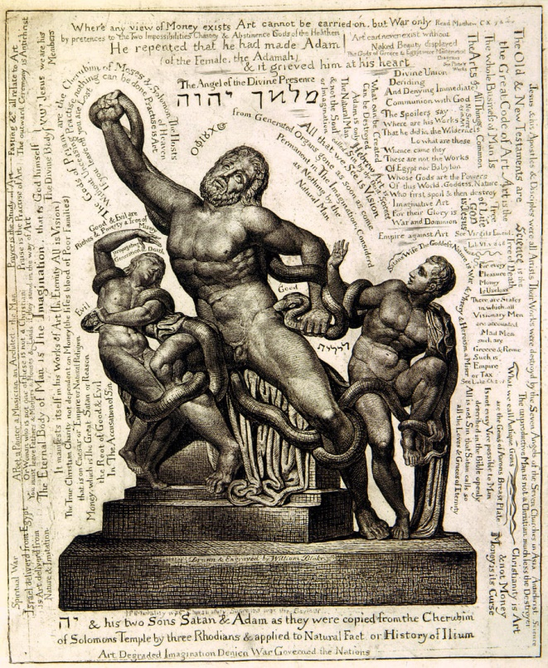
Laocoön and His Sons, (Source: William Blake Archive)

